Question 1:

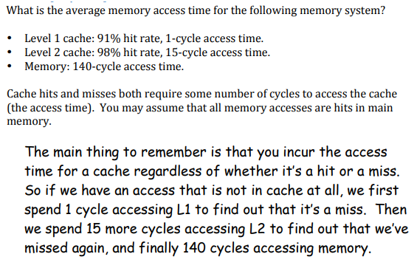

**Solution:**

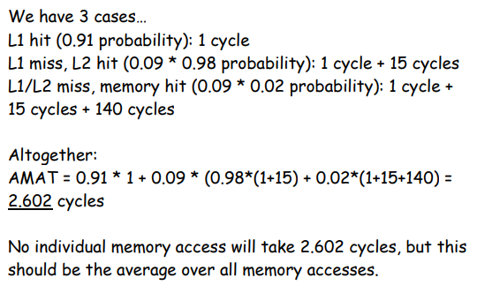

Question 2 and solution:

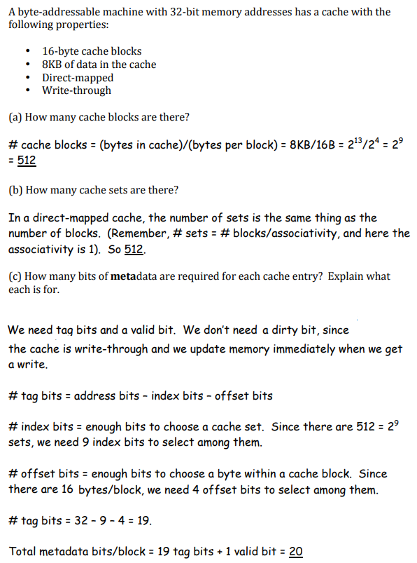

Question 3 and Solution:

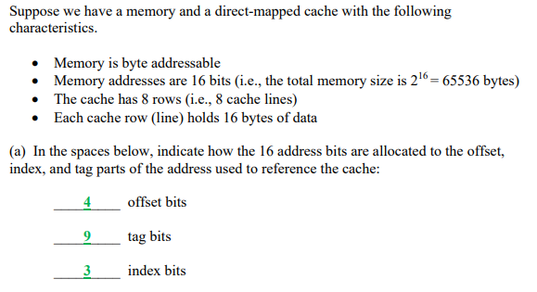

Question 4 and solution:

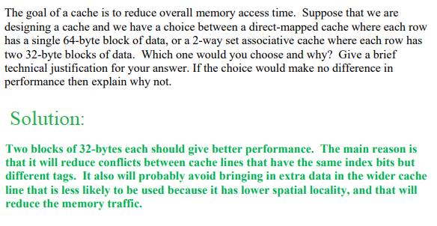

Question 4 and Solution:

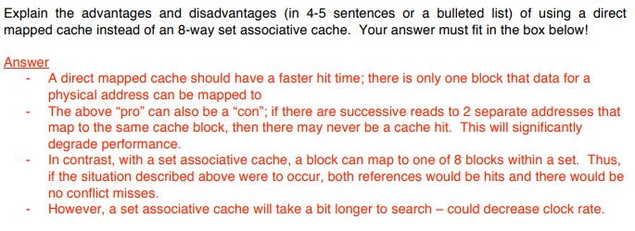

Question 5 and Solution:

Explain the difference between *direct-mapped*, *set-associative*, and *fully associative* cache designs.

In a direct-mapped cache a memory address maps to only one cache block. In a fully-associative cache a memory address maps to any cache block. In a set-associative cache a memory address maps to a particular set of cache blocks.

Question 6 and Solution:

Show how 32-bit addresses are divided into tag, index, and offset given the following cache descriptions:

32KB, byte addressable, 8-way set associative cache with 4 byte blocks.

**Solution**:

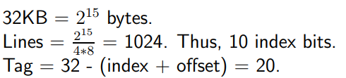

2 Offset bits

10 Index bits

20 Tag bits